**Define Unit Test Cases**

**Module Description**

Now that you have reviewed the design deliverables, it is now time for you to define the unit test cases and create work products for the unit test.

**Scenario**

You will thoroughly review the detailed design assigned to you. Then, determine what unit test cases should be created to test the class(es) you develop. These test cases, also called ‘Test Conditions and Expected Results’ (TCERs), will test the class to make sure it works correctly (as defined in the detailed design) and will be fully documented in the TCER template.

The work products that you will complete are the Unit Test Documents: TCER, Test Scenarios, and Test Cycle Control Sheet.

After you complete your work products, you will conduct a Peer Review.

**ADM Activity Context Diagram**

Application > 4100 Build Application > 4183 Create Unit Tests

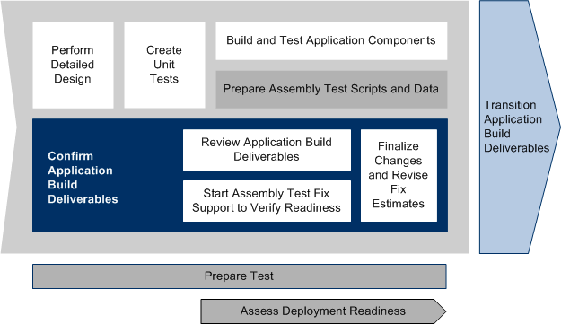

**Roles**

|  |  |  |  |
| --- | --- | --- | --- |
| **Role** | **ADM Task** | **ADM Responsibility** | **Description** |
| Developer | 4183 - Create Unit Tests | Primary Performer | Creates all the needed Unit Test Documentation to assist with building the automated Unit Test Scripts.  Peer Reviews another team member’s work products. |

**Participant Instructions**

1. Download a copy of the [Unit Test Conditions and Expected Results Template](https://accenture.desire2learn.com/content/enforced/9406-Pending/W3_Participant_Materials/Module_32/Unit_TestCond_FERS_R1_TMPL.xlsx?_&d2lSessionVal=YnoL4daZGC8ne2RyGf0cWMrk8).

2. Save a copy of the Test Conditions and Expected Results Template and rename it using this format: *Unit_TestScen_FERS_R1_<JavaClass>_<Team ID>_<Author Initials>.xlsx*.

3. Repeat Steps 1. and 2. above for the [Unit Test Scenarios Template](https://accenture.desire2learn.com/content/enforced/9406-Pending/W3_Participant_Materials/Module_32/Unit_TestScen_FERS_R1_TMPL.xlsx?_&d2lSessionVal=YnoL4daZGC8ne2RyGf0cWMrk8), using format: *Unit_TestCond_FERS_R1_<JavaClass>_<Team ID>_<Author Initials>.xlsx*.

4. Repeat Steps 1. and 2. above for the [Unit Test Cycle Control Sheet Template](https://accenture.desire2learn.com/content/enforced/9406-Pending/W3_Participant_Materials/Module_32/Unit_TestCycle_FERS_R1_TMPL.xlsx?_&d2lSessionVal=YnoL4daZGC8ne2RyGf0cWMrk8), using format: *Unit_TestCycle_FERS_R1_<JavaClass>_<Team ID>_<Author Initials>.xlsx*.   
**Note:** This will be used by Team Leads only.

5. You will be assigned a detailed design to work with throughout this module.

6. Focus in particular on the following classes and class methods (and the documented complexity of each class listed in parentheses). You will write test documentation for these classes now and you will test them later in this course:

a. EventServiceImpl.java (SIMPLE)

i. checkEventsofVisitor()  
ii.getAllEvents()  
iii.updateEventNominations()

b. EventDAO.java (MEDIUM)

i. showAllEvents()  
ii. updateEventDeletions()  
iii.checkEventsofVisitor()

c. VisitorServiceImpl.java (SIMPLE)

i. createVisitor()  
ii. searchVisitor()  
iii. registerVisitor()  
iv. showRegisteredEvents()

d. VisitorDAO.java (COMPLEX)

i. insertData()  
ii. searchUser()  
iii.registerVisitortoEvent()  
iv.registeredEvents()

7. Using the detailed design that was assigned to you, perform the following:

a. Open your saved Unit Test Conditions and Expected Results work product.

b. Complete your saved Unit Test Conditions and Expected Results work product with all the needed test conditions (positive and exception) and save. **Note:** It is recommended to list all your positive test conditions, then, list all of your exception test conditions. It will be easier to group later into test scenarios and test cycles.

c. Open your Test Scenarios work product.

d. Add Test Scenarios to your Test Scenarios work product and save.

e. From the Test Conditions and Expected Results work product, copy individual test conditions to their appropriate Test Scenarios in the Test Scenarios work product. When completed:

i. The Test Scenarios work product should have a list of Test Scenarios each containing at least one sub-scenario. For each sub-scenario, there would be one or more Test Conditions with expected results.

ii. All the test conditions in the Unit Test Conditions and Expected Results data should be in the Scenarios work product.

iii. Consider defining a test scenario as a group of:

1. All the positive test conditions for a class method  
2. All the exception test conditions for a class method

8. Open the Test Cycle Control Sheet.

9. Group the Test Scenarios into Test Cycles in the Test Cycle Control Sheet. **Note:** Consider putting all the positive test conditions for all the methods in one cycle and the exception conditions in another cycle.

10. Go to this module's Peer Review page for information on how to conduct a peer review of the work products created in this module.

**Hints and Tips**

You can't test every possible input, but there are some aspects you can test completely in your code.

Consider the different levels of code coverage (statement, branch, and condition) to help you determine the most critical test conditions.

Consider the scope of a unit test, and thus, what would make up a Test Scenario and a Test Cycle.

Get all your deliverables peer-reviewed once completed to make sure your tests are efficient.